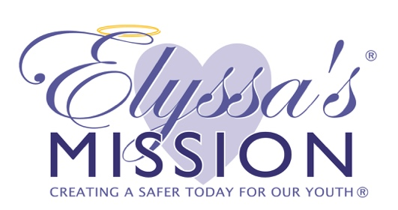

**SOS Program: Best Practices for Scheduling & Implementation**

The SOS program can be implemented anytime September-May. Elyssa’s Mission highly recommends that partnering schools defer programming until *at least* the third full week of school (for returning SOS participants) and *at least* the fourth full week of school (for “new” SOS participants) to allow students time to transition into their new school and/or school year.

Please consider the following recommendations when selecting your SOS Days:

* Tuesday, Wednesday, Thursday are preferred days for SOS programming
* Avoid Mondays (if possible) due to increased absences following the weekend and “tired” students; in the event of Monday programs, attempt to avoid first period SOS lessons
* Avoid Fridays as this would inhibit follow-up with “Priority 2” students according to the rubric guidelines (i.e., “Priority 2” students should be followed up within 24-48 hours). If the program were to occur on a Friday, in the likely event that not all P2 students could be seen on the SOS program day, these students would not receive follow-up until at least Monday. Furthermore, parent calls/referrals to community organizations cannot always be completed “day-of,” especially if numbers of “Priority 1” referrals are high. In such cases, these calls should be made the following school day—which would not be possible in the event of Friday programming.
* Avoid the week prior to and following extended holidays such as winter or spring break
* Avoid the week of Thanksgiving
* Avoid the first day or two following shorter holidays such as Thanksgiving or “long weekends”
* Avoid scheduling SOS on “alternative schedule” days (e.g., late start, early release, planned safety drills, planned assemblies, etc.)
* Encourage teachers to avoid scheduling tests, quizzes or presentations on SOS days as some students will necessarily be pulled out of class for follow-up interviews throughout the day