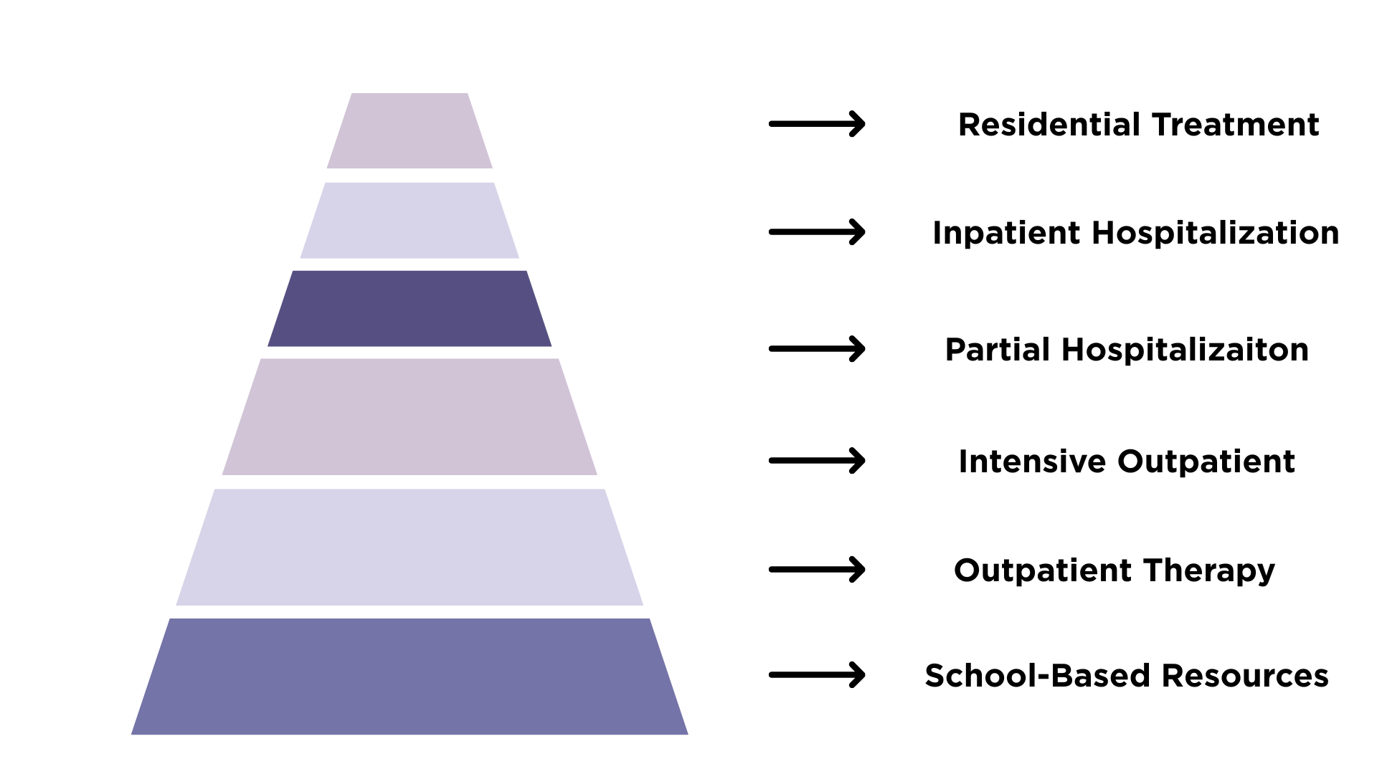
School-Based Resources
- Individual and/or small group sessions with school counselors, social workers, or psychologists
- Low levels of stress or anxiety, and/or has minor difficulties managing emotions and/or navigating peer relationships
Outpatient Therapy
- Weekly or biweekly individual therapy sessions with licensed professional
- Family sessions may also be incorporated
- Focus on coping skills, emotional regulation, and problem-solving
- Medication management may be indicated
Intensive Outpatient Programs (IOPs)
- Meet several days per week, usually after school
- Group therapy and skill-building
- Sometimes individual and family sessions
Partial Hospitalization Programs (PHPs)
- 5 days a week for most of the day, during the school day
- Structured, therapeutic support without overnight stays
- Symptoms are significantly interfering with daily life, and your child needs more support than weekly therapy or IOPs can provide
- Medication management with a psychiatrist
Inpatient Hospitalization
- Immediate risk of harm to themselves or others, or is unable to stay safe
- 24/7 monitoring in a hospital setting
- Crisis stabilization
- Medication evaluation and adjustment
- Short-term care focused on safety (3-7 days)

Residential Treatment
- Longer-term stays of about 30 days or more
- Non-medical setting
- Highly structured days with 24/7 care
- Individual, group, and family therapy
- Medication management
- Recreational therapies (art, music, movement, etc.)

How to Get Started
Call nearest behavioral health hospital and request a mental health assessment or level of care assessment
- Walk-ins available
- Free-of-cost, regardless of insurance

Recommended going to a behavioral health hospital and not an ER
- Shorter wait times
- Specialize in these assessments

What to Expect During an Assessment
Meet with a licensed clinician both separately and together with your child to discuss things such as:
- Symptom onset and duration
- Changes in behavior such as withdrawal and isolation
- Lack of interest in hobbies and activities
- Drop in grades
- School concerns and issues with peers
- Issues pertaining to daily functioning, such as poor eating and sleeping habits and poor hygiene
- Safety concerns including:
    - Drug and alcohol use
    - Self-harming
    - Researching ways to die or “preparing” for suicide
    - Indirect and direct statements about suicide

